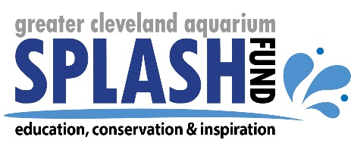

Education Department Internship

Description: Bring together your love of teaching and love of science at the Greater Cleveland Aquarium. Here you can shadow aquarium educators to gain hands-on experience in the areas of education program delivery, program development, and classroom management. You will gain valuable experience for a career in informal science education or formal classroom teaching.

Length of Internship: 10 - 12 weeks with a commitment of 10 to 15 hours per week, Summer 2019

Reports to: Director of Education and Interpretation

Requirements:
- Be currently enrolled in a college or university
- Major in elementary education, biology, environmental science, or related field
- Have a minimum of one year of course work in the major field of study
- General knowledge of education fundamentals and basic science – knowledge of aquatic life preferred
- Must be motivated to work both independently and as part of a team
- Take and carry out multiple instructions in a timely manner
- Previous experience working with children preferred
- Complete a final project
- Pass required background check

Duties:
- Shadow education staff and eventually lead summer education programs
- Learn to present guided tours of the aquarium to guests ranging from preschool age to adult
- Learn operational standards for group check in, program logistics, classroom set up, and clean up
- Assist with development of new education programs
- Give informal presentations that focus on specific topics or exhibits
- Learn to interact with guests to provide informational and entertaining content
- Develop, complete, and present a final project to the education department staff

Compensation: Internship is unpaid. Performance-based stipend ($400) is available upon internship completion.

Please direct questions and submit resume to:
Erin Carpenter
Director of Education and Interpretation
ecarpenter@greaterclevelandaquarium.com

